Experiment no-15
Online Complaint Management System
AIM:
To develop an online toll payment website for managing toll passes, e-tickets, and toll payments.
PROCEDURE:
- Create a webpage with user login.
- Provide an option to enter the toll amount.
- Add a button to pay the toll amount.
- Display the payment confirmation.
- Run the webpage in a browser.
Sample Code:
<!DOCTYPE html>
<html>
<head>
<title>EasyToll</title>
</head>
<body>
<h2>EasyToll Payment</h2>
<input type="text" id="vehicle"
placeholder="Vehicle Number">
<input type="number" id="amount"
placeholder="Toll Amount">
<button onclick="pay()">Pay Toll</button>
<p id="out"></p>
<script>
function pay() {
let vehicle = document.getElementById("vehicle").value;
let amount = document.getElementById("amount").value;

if (vehicle && amount > 0) {
document.getElementById("out").innerText =
"Toll payment request for " + vehicle +
" : ₹" + amount;
} else {
document.getElementById("out").innerText =
"Enter valid vehicle number and amount.";
}
}
</script>
</body>
</html>
Sample Output:
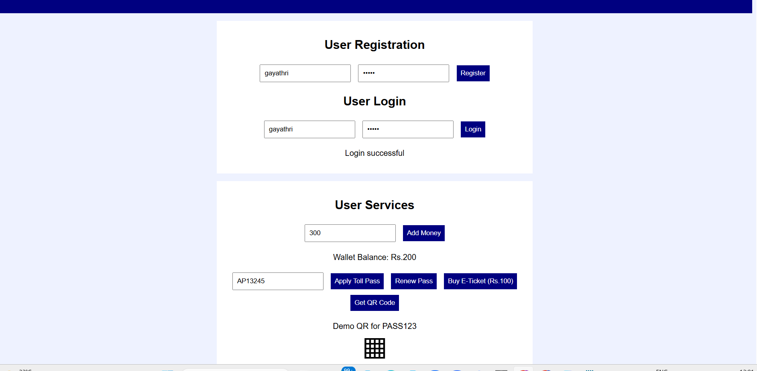
Result: The ComplainEase webpage was created successfully with complaint submission and status display.

